EXPERIMENT 4.1

|  |  |
| --- | --- |
| NAME | ASHEEM KHAN |
| UID | 23BCS13395 |
| CLASS | 622-B |

PART – A

CREATE TABLE FeePayments (

payment_id INT PRIMARY KEY,

student_name VARCHAR(100) NOT NULL,

amount DECIMAL(10,2) CHECK (amount > 0),

payment_date DATE NOT NULL

);

START TRANSACTION;

INSERT INTO FeePayments VALUES (1, 'Ashish', 5000.00, '2024-06-01');

INSERT INTO FeePayments VALUES (2, 'Smaran', 4500.00, '2024-06-02');

INSERT INTO FeePayments VALUES (3, 'Vaibhav', 5500.00, '2024-06-03');

COMMIT;

SELECT * FROM FeePayments;

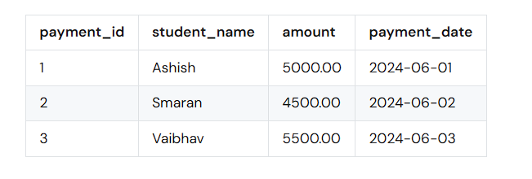

PART-B

START TRANSACTION;

INSERT INTO FeePayments VALUES (4, 'Kiran', 6000.00, '2024-06-04');

INSERT INTO FeePayments VALUES (1, 'Ashish', -2000.00, '2024-06-05');

ROLLBACK;

SELECT * FROM FeePayments;



PART-C

START TRANSACTION;

INSERT INTO FeePayments VALUES (5, 'Ravi', 4000.00, '2024-06-06');

INSERT INTO FeePayments VALUES (6, NULL, 7000.00, '2024-06-07');

ROLLBACK;

SELECT * FROM FeePayments;



PART-D

START TRANSACTION;

INSERT INTO FeePayments VALUES (7, 'Neha', 8000.00, '2024-06-08');

INSERT INTO FeePayments VALUES (1, 'DuplicateTest', 1000.00, '2024-06-09');

ROLLBACK;

START TRANSACTION;

INSERT INTO FeePayments VALUES (8, 'Manish', 6500.00, '2024-06-10');

COMMIT;

SELECT * FROM FeePayments;

